Brief Report: Workshop on “Gender at Work: Building Respectful, Inclusive Workspaces”

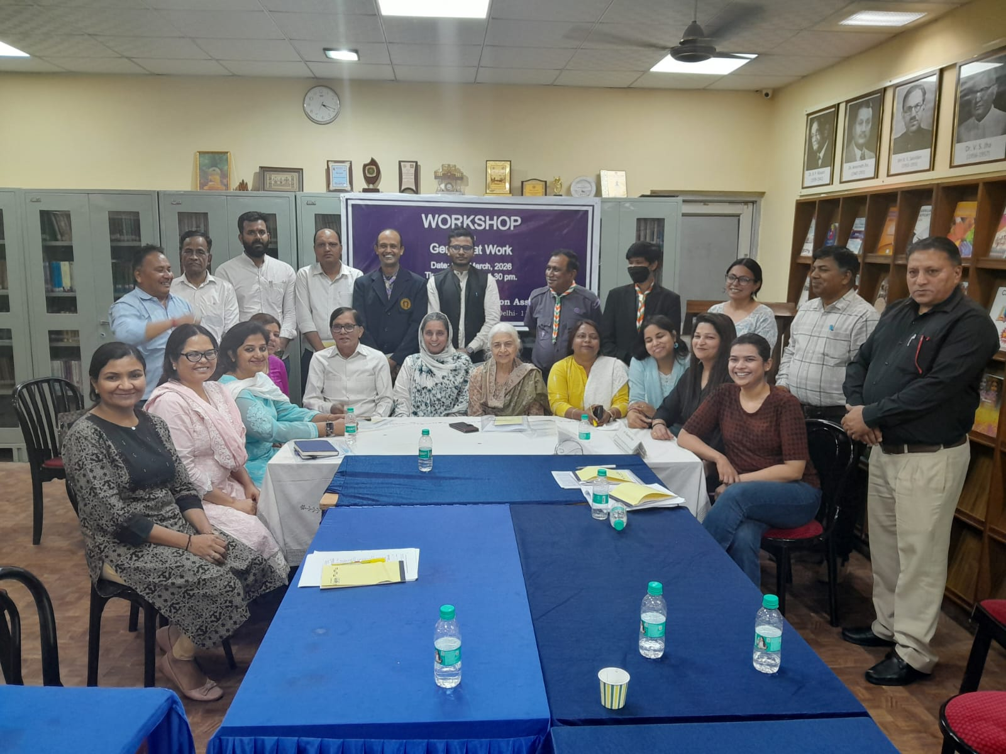
A workshop on “Gender at Work: Building Respectful, Inclusive Workspaces” organised by ICC, Indian Adult Education Association was held today on 24 March 2026 at KC Memorial Hall, IAEA, New Delhi. The main aim of the workshop was to increase awareness about gender issues, reduce workplace bias, and promote inclusive and respectful work environments.
The programme started with tea at 10:30 a.m., followed by the inaugural session in which Smt. Nishat Farooq, Chairman of the Committee welcomed all the participants and explained the purpose of the workshop. Dr. Sujata, Associate Professor at Shyamlal College, conducted a fun activity called “Gender Lens,” which helped participants understand how gender affects everyday decisions.
The second session was chaired by Dr. Joycia Thorat, ICC Member in which participants learned about basic gender concepts. Dr. Sujata explained the difference between gender and sex and discussed common gender roles, especially focusing on women’s responsibilities in urban India.
The third session was chaired by Dr. Gyanendra Kumar, Member ICC, who highlighted gender disparities in health as well as in work place. Prof. Rajyalakshmi, Professor at Janki Devi Memorial College (JDMC), University of Delhi, emphasized equal opportunities for both men and women and the need for balance at both the workplace and societal levels. She discussed the concepts of nature versus culture and explained that societal bias often comes from value systems and structures of authority. She further noted that core jobs are often occupied by men, while women are often given peripheral roles, reflecting a clear gender-based division of work.
After lunch session was focused on legal awareness which was chaired by Dr. Geeta Mishra. The resource person, Advocate Nilofar Khan (Advocate, Supreme Court; Former AAG, Rajasthan Government), explained the Prevention of Sexual Harassment (POSH) Act, workplace rules, and the importance of maintaining a safe work environment.
The concluding session was chaired by Dr. Chayanika Uniyal, who allowed participants to share their ideas and suggestions. Activities included group discussions, anonymous feedback, and creating plans for inclusive workplaces. The session ended with reflections and feedback.
Along with the members of staff of IAEA a total of 35 participants representing organizations such as IGNOU, Bharat Scouts and Guides, GST, Directorate General of Performance Management, Rajiv Gandhi Study Circle, attended the workshop. Each participant found it very useful for enhancing their understanding about gender issues and requested IAEA to do such activities in future also. The Committee expressed their heartfelt thanks to Prof. Raja, President, Shri Suresh Khandelwal, General Secretary and Prof. Rajesh, Director I/c for their continuous support and guidance.
The workshop was concluded with the vote of thanks extended by Ms. Neha Gupta, who played key role in organising the workshop.

